How to operate SLM 8000 Spectrofluorometer (with ISS Phoenix Upgrade)

SLM8000 Spectrofluorometer is a research grade instrument capable of measuring steady state fluorescence excitation & emission spectrum, as well as nanosecond fluorescence lifetime. Below is the operating procedure for steady state and time-resolved instrument configuration.

Table of Contents

Instrument Diagram1

Steady State Fluorescence Emission & Excitation Operation2

Troubleshooting6

Fluorescence Lifetime Measurement Operation7

Troubleshooting10

1. Instrument Diagram:

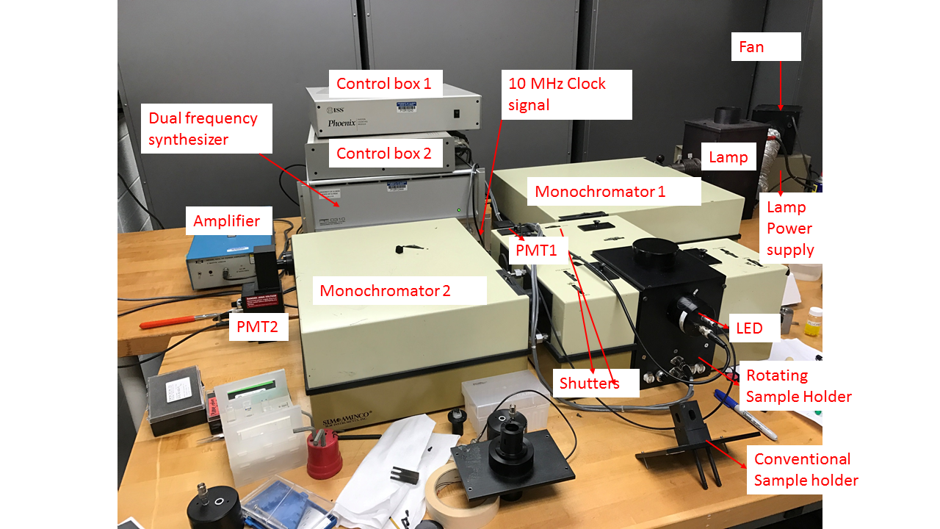

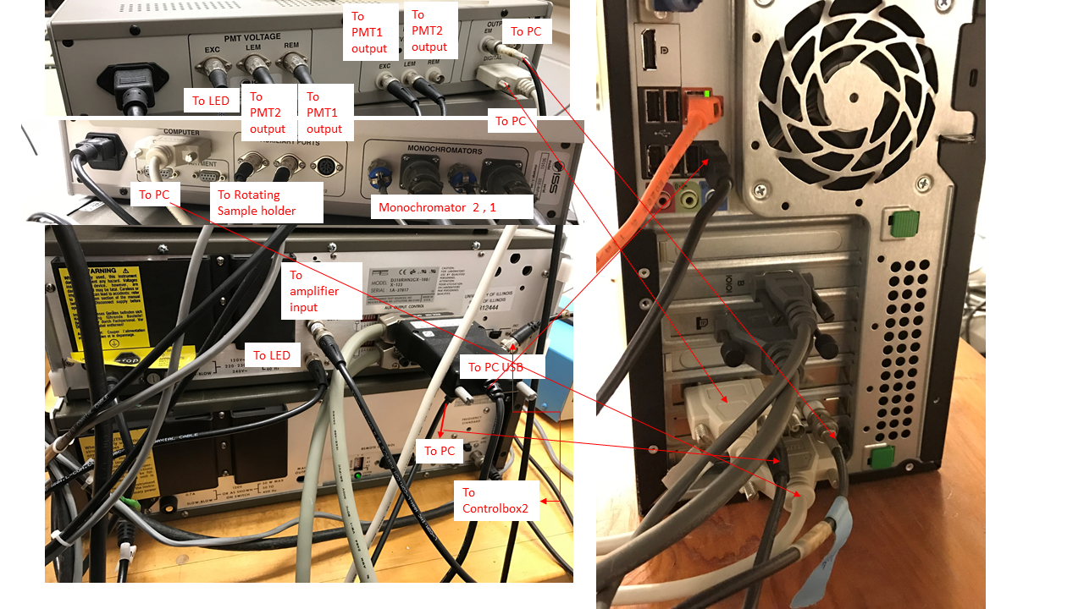

1. Steady-State Fluorescence Emission, Excitation Operation
   1. Change sample holder from rotating sample holder to conventional sample holder. The holder should be held by 2 rails that needs to be screwed on to the inside of the sample chamber.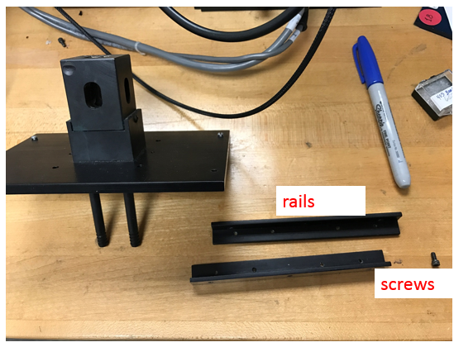
   2. Plug in the fan to a power outlet, make sure the fan really turned on.
   3. Turn on the lamp from the lamp power supply box. You will hear a few clicks before the lamp turns on.
   4. Turn on Control box 1 & 2
   5. Open vinci software on the desktop by clicking “experiment-shortcut”, pick the “SLM 8000” configuration. You should hear the monochromator moving and hitting the limit switch (sounds like light click). You should get to this window. 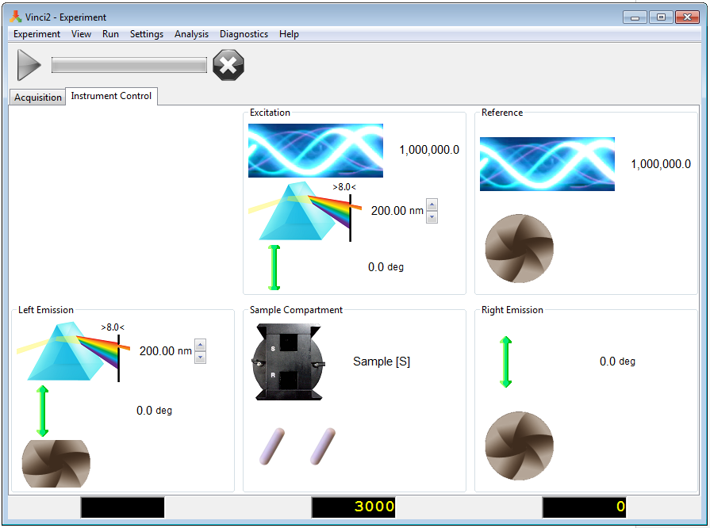
   6. For measuring emission spectrum, go to the top left hand corner click “experiment”, then “spectra” then “emission”.
   7. If you arrive at this window and receives an error msg. 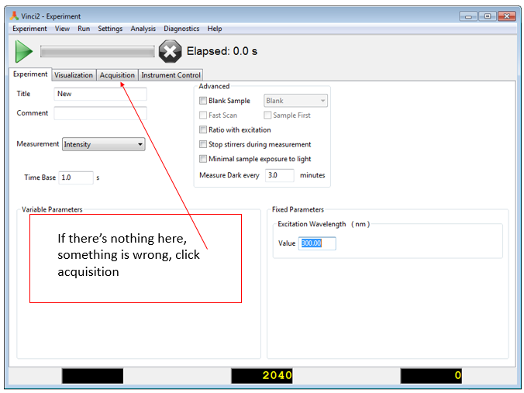
   8. If the variable parameter is blank, you need to go to the “acquisition” tab on the top next to instrument control and visualization tabs. If variable parameter is not blank and you see emission waveleng selections, then you can ignore and skips ahead to step j. Under acquisition control, there are 3 configurations, click the one going to the left (not the upside T or L). 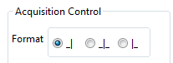
   9. Go back to the experiment tab, right click the blank area under variable parameters, click “add”, and check the box for left emission wavelength.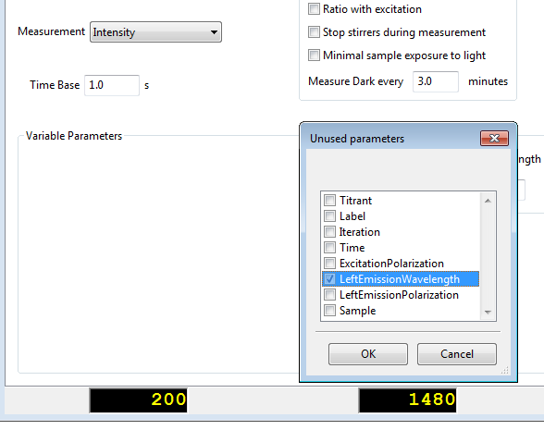

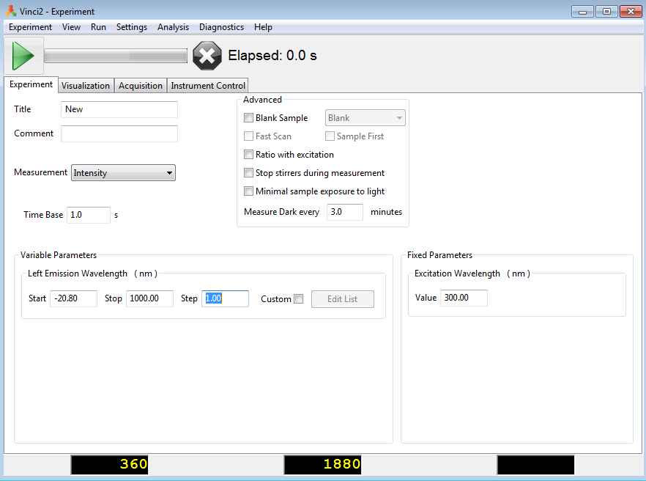

* 1. Left emission wavelength, enter a start/stop emission wavelength. Start emission wavelength is always smaller than stop emission wavelength. For instance, for ruby, start: 680 nm and stop 720 nm. For Step, you can go down to 0.5 or 0.25 for finer wavelength selection, but it takes twice or four-times as long to scan the spectra.
  2. For excitation wavelength box on the right, enter the wavelength that can excite your sample, for ruby, 400 nm will work.
  3. Go to settings on the top of the software panel, click “software” this window should appear:\

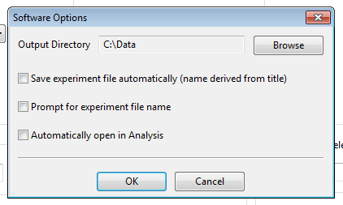

You can select where in directory you want the file to be saved by clicking “browse”. Check the “save experiment file automatically “ and “automatically open in analysis” box. Click ok.

* 1. You are ready to scan, click the green arrow on the top.
  2. 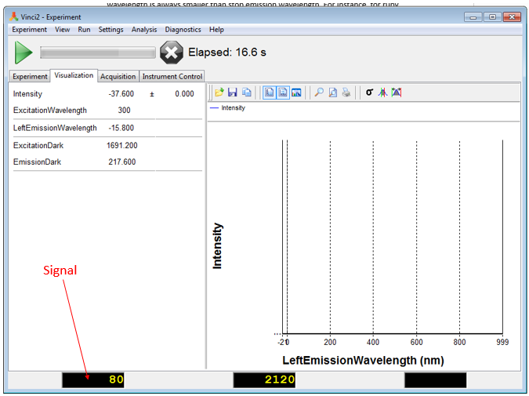
  3. Monitor your signal closely at the peak emission wavelength to make sure its not saturated, when saturated the number will appear in red.
  4. When turning off the software, give the machine time to return everything to position, DO NOT FORCE SHUT DOWN THE PROGRAM.

1. Troubleshooting:
   1. I cannot see ruby’s fluorescence peak at ~694 nm: make sure the shutter is open on the left of the sample chamber.
   2. I only see one huge peak at 694 nm instead of two peaks stated by many literatures: if you see one peak instead of two peaks, it means your wavelength resolution is not good enough. Improve the resolution by decreasing “step” size from 1 nm to 0.5 nm. Narrow the slit by changing the slits on monochromator 2 to 1 or 0.5 (slit is a rotating black wheel that ranges from 16, 8, 4, 2, 1, and 0.5), smaller the slit, more resolution you will get, but also less the signal. You need to narrow both slits on monochromator 2 to see a change.
   3. How do I open the data files?: The data files (ifx) can be opened in excel. The rows/columns of data are at the end. You can divide them up into columns using excel, data, text to column feature.
2. Fluorescence Lifetime Measurements:
   1. Check the sample holder, it should be the rotating sample holder instead of conventional sample holder. Remove the rails on the inside of the sample chamber to swap sample holders. The cables with S and T stickers should be on top/bottom of the sample holder respectively. The LED laser diode (448 nm for fluorescein) should be screwed on tightly to the sample holder. A bandpass filter (for example, 450 nm +/- )should be placed in the holder after the LED has been screwed on. 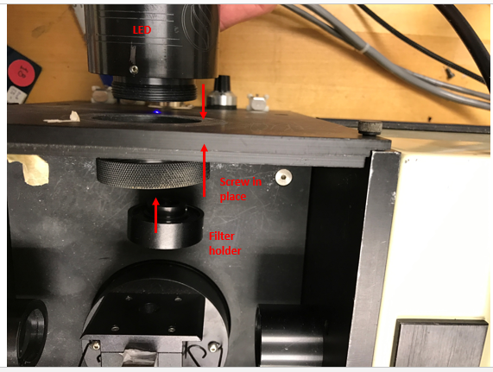
   2. Turn on control box 1, control box 2, amplifier, dual freq synthesizer should be on by default (green LED is on in the front panel), 10 Mhz output switch in the front should be flipped on if it hasn’t already.
   3. Open vinci software by clicking “experiment” icon on the desktop. Select the “SLM 8000 freq”profile.
   4. Select Experiment on the top, then frequency domain, then lifetime. This window should show up: (If it doesn’t, see Step “g” in steady-state fluorescence operation).
   5. 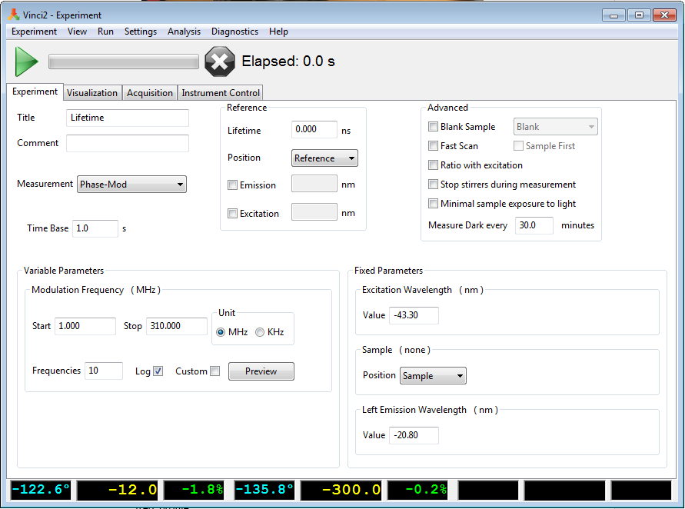
   6. For smoother time points, enter 3.0 s for time base. For modulation frequency, generally use 20 MHz to 100 MHz (frequencies below 20 MHz and above 100 MHz are unstable). For frequencies enter at least 10. Excitation wavelength is irrelevant because we are using an LED with fixed wavelength. Left emission wavelength should be the peak or near the peak emission wavelength of the sample.
   7. For reference information, enter the lifetime of a known reference you are using. You need to prepare a reference sample using a dye that you know the lifetime of. Typically, for measuring dye similar to the emission wavelength of fluorescein, you can use fluorescein as the reference (lifetime = 4.1 ns) or acridine orange (lifetime = 2.0 ns in Phosphate buffered saline).
   8. Check whether the emission intensity at the given wavelength is not too strong or too weak for the PMT detector by click the Instrument control top on the top, just below the X sign.
   9. Move the left emission monochromator to the emission wavelength peak that you entered. For example, for fluorescein I will use 510 nm as emission wavelength. The emission monochromator can be moved by right clicking the emission monochromator symbol (red rectangle), and click “move”, set it to 510 nm, or the peak wavelength of your dye of interest. 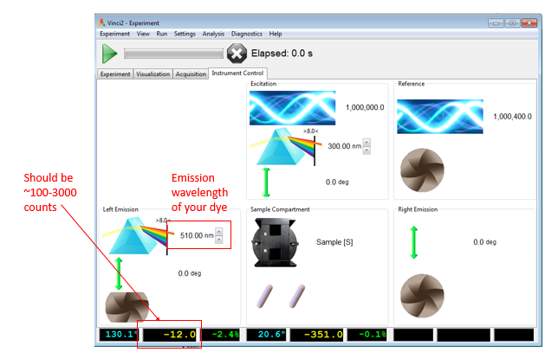
   10. Check the intensity counts, make sure is between 100-3000 counts. If the count is too low, more signal can be acquired by opening up the two slits on the monochromator 2. Slits are the black wheels with number that says 16 ,8 ,4, 2, 1, 0.5. Making the number larger gives you more intensity. If that doesn’t make it much higher, increase concentration of the sample. Otherwise, adjust the position of the LED by rotation or translation (it has limited translational freedom) to maximize the signal.
   11. Check the intensity counts of both your sample and the reference. \*\*Make sure your sample is in the “sample” slot on the sample holder, and reference is in the “reference” slot. \*\* Ideally, the emission wavelength of the sample and the reference should be identical. Even if it is not at the absolute peak emission wavelength for one of the dye, it’s better to set the two emission wavelength the same.
   12. Click the “setting” option at the top of the software, click software. Here you can choose where to save your file by clicking browse. Also check the two options, save data automatically as well as automatically open in analysis. 
   13. Before starting the measurement, the shutter should be in closed position. Shutter is the black wheel next to the sample holder, on the left. Click the green play bottom on the top to begin your measurement.
   14. At the end of experiment, in analysis software, click on fitting at the top, then lifetime. 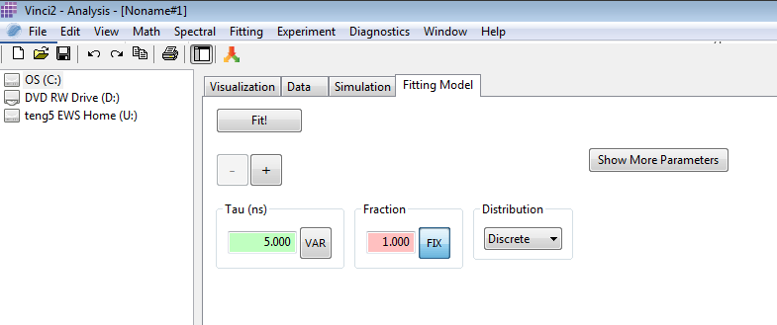
   15. The above window should appear. IF you know your sample contains a single lifetime, click FIT!, and you can see how well your data fit to a single lifetime. To add more lifetime component to the fit, click the + button for as many lifetime component you think you have, and click FIT!.
   16. When turning off the software, give the machine time to return everything to position, DO NOT FORCE SHUT DOWN THE PROGRAM.
3. Troubleshooting for frequency domain lifetime measurement:
   1. MY modulation/phase plot is very noisey, fit is bad: check if your cuvette is clean, and without floating particles. Keep you eyes on the signal box at the bottom left hand corner (see step i), and that number should NOT vary too much for a given frequency. The number will change when sample rotates, and you know when the sample rotates by listening to the sample holder turn. But at a given measuring frequency the number should be relatively stable. Number that decrease constantly means dye is being photobleached, you will need to add some filters to block the laser intensity from being too high. If the number jumps around, large particle is floating around in the cuvette. Also, make sure that you have turned on the blue amplifier, it makes a constant loud roaring noise. Also, make sure your liquid level is high enough in the cuvette for the laser to pass through.
   2. I’m seeing some multiple component of lifetime in a single component sample: Clean the cuvette better, avoid sample contamination by making new sample.